Half-Adder Gate:

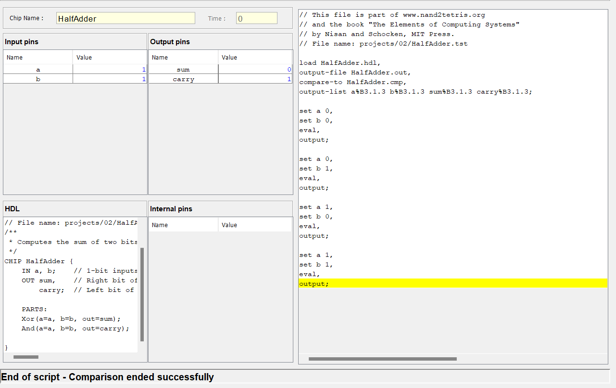

Full-Adder Gate:

Add16:

